Tab 1

Home  
About US

Accounting   
 Property Management Accounting

Bookkeeping and Tax Service (USA)  
 Accounting and Tax Service (Australia)

AppFolio

AppFolio Bookkeeping Service  
 AppFolio Administration Service

Buildium   
 Buildium Bookkeeping Service

Buildium Administration Service  
Virtual Assistant

Digital Marketing  
Blog  
Contact Us

Competitors

<https://www.cookcpaglobal.com/>

<https://ojobookkeeping.com/>

<https://www.igsbookkeeping.com/>

<https://www.velan-bookkeeping.com/>

<https://www.propertycpany.com/>

https://www.realestatecpafirm.com/  
<https://lavertychacon.com/>

<https://pmbookkeeper.com/>

<https://cocountant.com/>

<https://www.realestateaccounting.co/>

<https://northstar-bookkeeping.com/>

<https://www.propertymanagementbackoffice.com/>

<https://xs4-fm.com/>

<https://www.hcvt.com/>

<https://www.outsourcinghubindia.com/>

<https://confiancebizsol.com/>

<https://www.exoedge.com/>

<https://www.vertaccount.com/>

<https://www.apmhelp.com/>

<https://www.pacificabs.com/>

<https://www.acrebook.com/>

<https://spinacpa.com/>

<https://saveonbookkeeping.ca/>

<https://ossisto.com/>

<https://www.appfoliobookkeeping.com/>

Tab 2

*all H1, H2 tag use logo colour (color code Green#3DB375, Blue#263895)

Fix The Logo Left  
Nave bar is fixed now so use Scroller navebar  
Right Top use Mobile number with xxx and email id  
  
For background of site - Use background of below site  
https://martex-tailwindcss.ibthemespro.com/demo-17.html  
  
**Outsource** **Property Management Bookkeeping and Accounting Service**  
  
Logo of AppFolio, Buildium, Propertyware, Tenant Cloud, Rentec, Rent Manager, Rentvine QuickBooks, Xero, Sage, Yardi  
  
_________________________________________________________________________  
  
Second Scenario  
H2 tag- Right side - Outsource Property Management Accounting and Administration

Pacerline Outsourcing Services Pvt. Ltd. is a trustworthy partner offering end-to-end bookkeeping, accounting, administrative, and digital marketing services to real estate investors, property managers, homeowner associations (HOAs), and small businesses in the United States, Australia, and across the world. With over 13 years of experience, we combine matured expertise with state-of-the-art technology to deliver scalable, customized outsourcing solutions to help businesses focus on growth while we take care of their operation needs.  
  
Left side of the above content  


Our services  
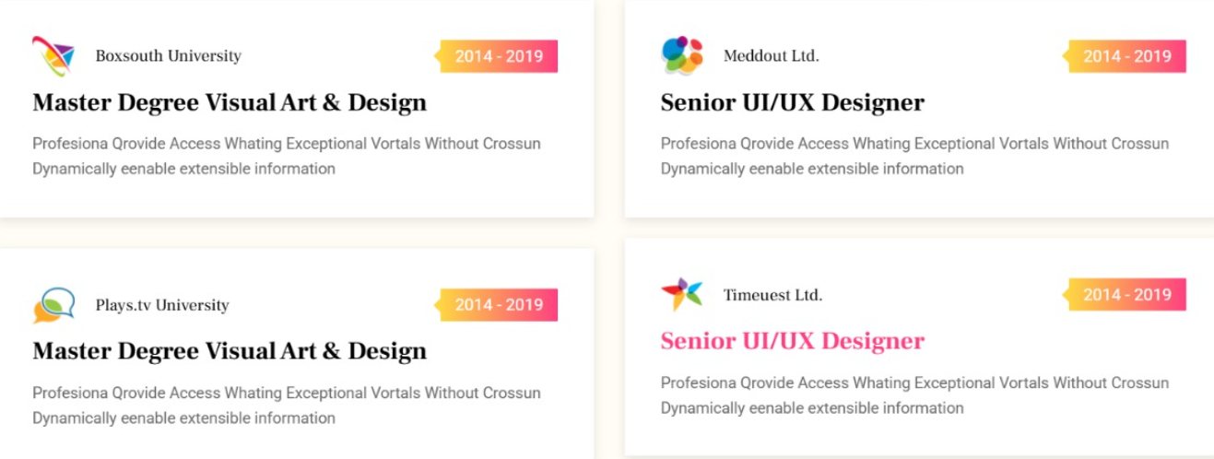  
  
Software name with logo  
AppFolio, Buildium, Propertyware, Tenant Cloud, Rentec, Rent Manager, Rentvine QuickBooks, Xero  
  
Our Process  
  
  
   
**Testimonials**  
  
**I will get it from clients  
  
  
Our Core Value**  
**Why  Choose Pacerline?  
  
Footer**